**Computer Networks**

**Lab Assignment Documentation**

**POOJA A**

**RA2211026050031**

**CSE AIML-A**

Lab 1: Introduction to Packet Tracer, Peer-to-Peer Communication, Study of Cables and its Colour codes

**Procedure:**

1. Open Packet Tracer:
   * + Launch Cisco Packet Tracer on your computer.
     + Familiarize yourself with the interface, including the workspace, device selection, and tools.
2. Create a Simple Network:
   * + Drag two computers (PC-PT) onto the workspace.
     + Drag a switch (Switch-PT) onto the workspace.
     + Connect each computer to the switch using straight-through Ethernet cables.

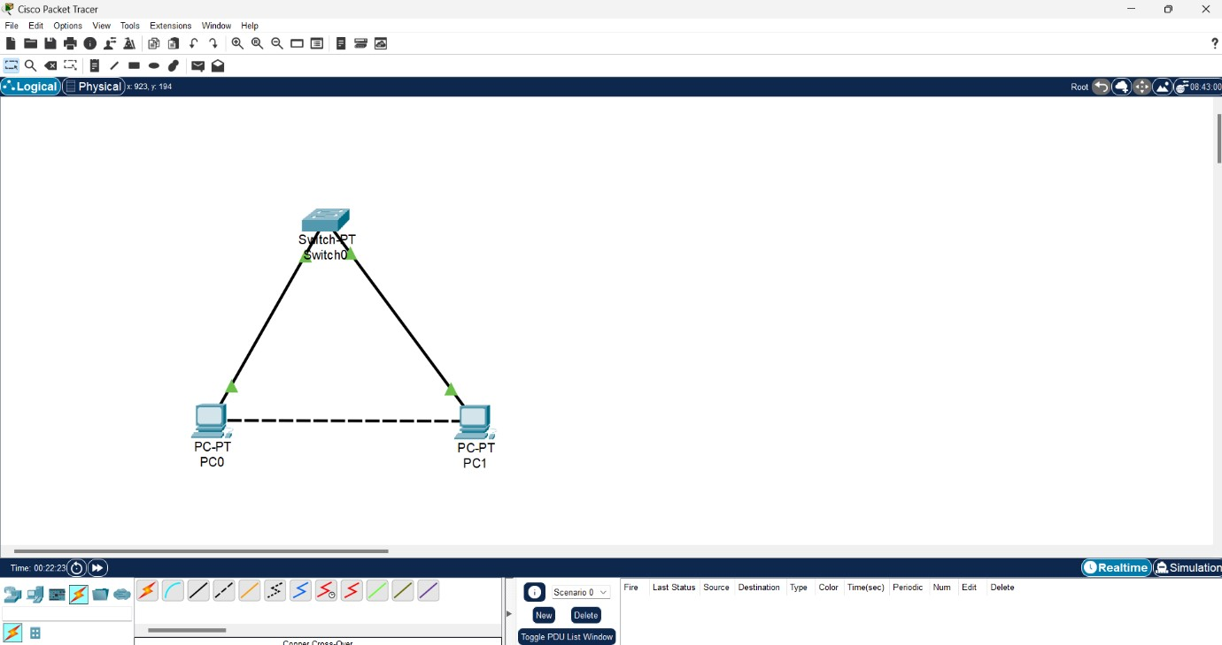

1. Configure IP Addresses:
   * Click on the first computer, go to the Desktop tab, and select IP

Configuration.

* + Assign an IP address (e.g., 192.168.1.1) and a subnet mask (e.g., 255.255.255.0).
  + Click on the second computer, go to the Desktop tab, and select IP Configuration.
  + Assign an IP address (e.g., 192.168.1.2) and a subnet mask (e.g., 255.255.255.0).

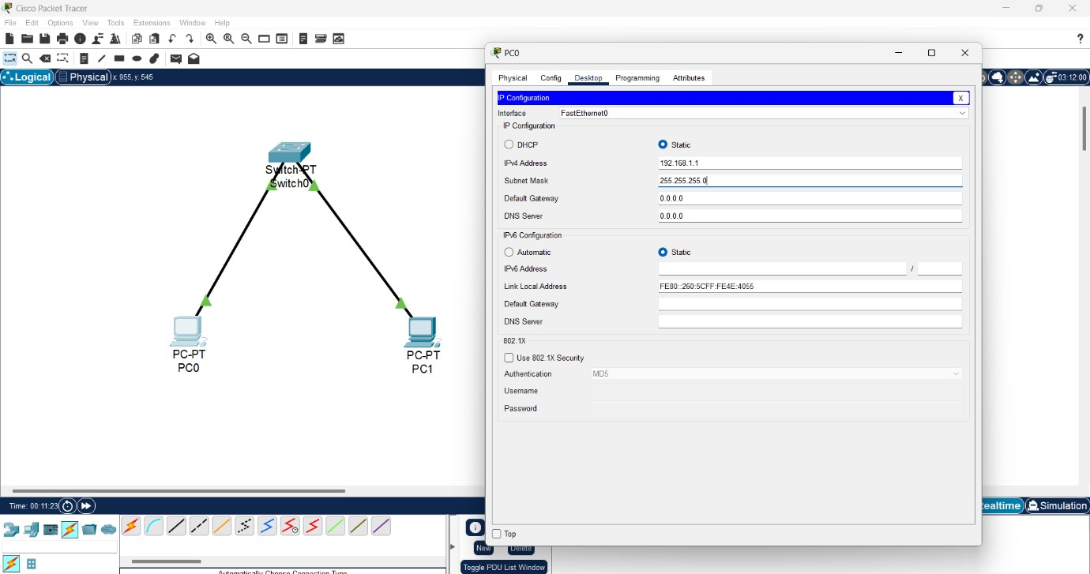

For PC 1

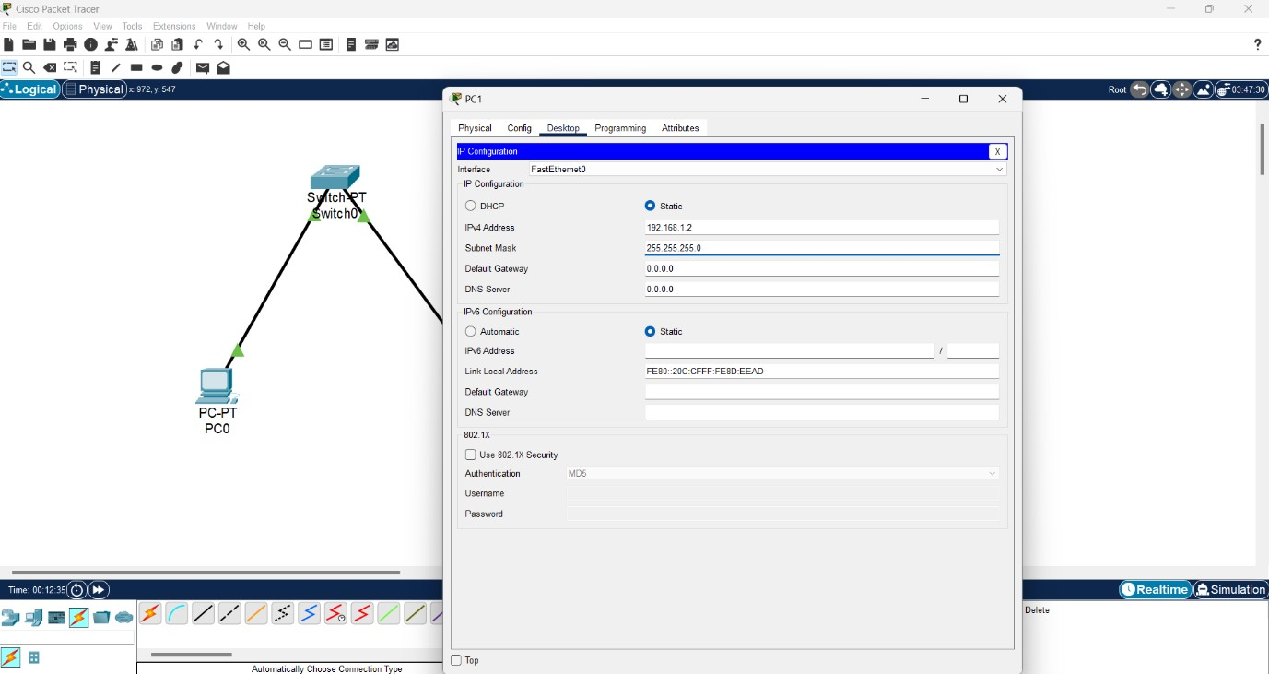

For PC 2

1. Test Peer-to-Peer Communication:
   * + On the first computer, open the Command Prompt from the Desktop tab.
     + Use the ping command to test connectivity to the second computer (e.g., ping 192.168.1.2).
     + Observe the response to ensure the computers can communicate

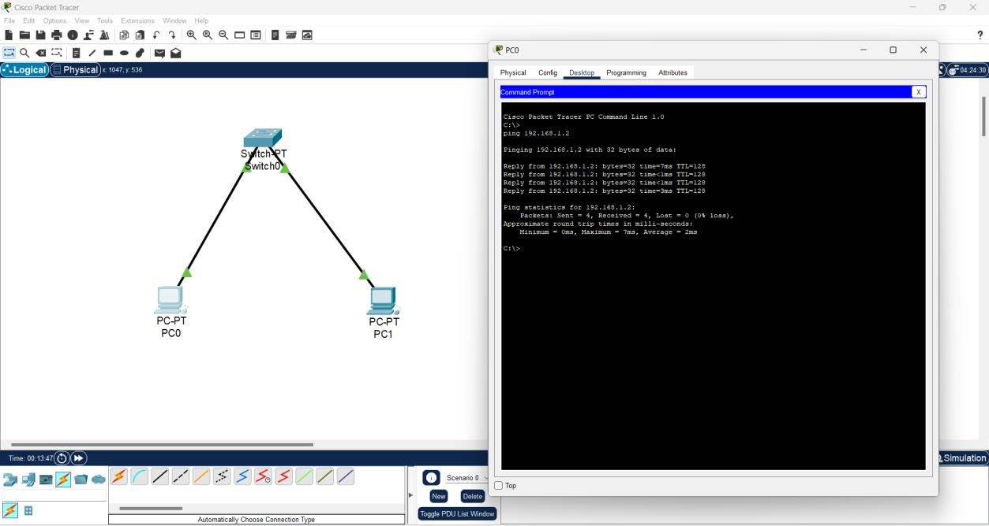

1. Study Cables and Colour Codes:

■ Examine different types of network cables provided (Ethernet, crossover).

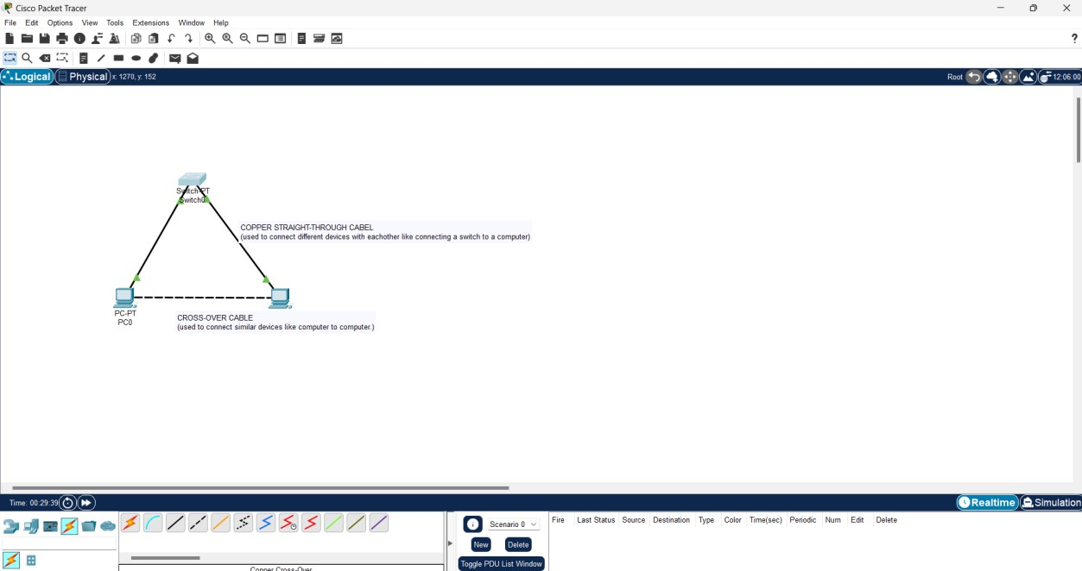

Different types of network cables used in computer networking are as follows:

# Twisted Pair Cables

1.1) Unshielded Twisted Pair (UTP)

UTP cables consist of pairs of wires twisted together to reduce electromagnetic interference (EMI). There is no additional shielding, making them more flexible but also more susceptible to interference.

* Categories:
  + - **Cat 3**: Used for voice communication (telephones) and older Ethernet networks (10Base-T).
    - **Cat 5**: Supports up to 100 Mbps (100Base-TX Ethernet). o **Cat 5e**: Enhanced version of Cat 5, supports up to 1 Gbps (Gigabit Ethernet).
    - **Cat 6**: Supports up to 10 Gbps for short distances, better performance than Cat 5e.
    - **Cat 6a**: Enhanced Cat 6, supports 10 Gbps over longer distances.
    - **Cat 7**: Supports up to 10 Gbps with added shielding for each pair and the cable as a whole.
    - **Cat 8**: Supports up to 40 Gbps, typically used in data centers.

1.2) Shielded Twisted Pair (STP)

STP cables include additional shielding to protect against EMI. This makes them suitable for environments with high interference, like industrial settings.

* Categories: Similar to UTP (Cat 5, Cat 6, etc.), but with added shielding.

# Coaxial Cables

Coaxial cables have a single copper conductor at the center, surrounded by a plastic layer for insulation, a braided metal shield for protection from EMI, and an outer plastic sheath.

* Uses:
  + **Cable Internet**: Used by ISPs to provide broadband internet.
  + **TV**: Commonly used for cable television signals.
* Types:
  + **RG-6**: Used in modern cable installations. o **RG-59**: Used in older TV setups, now less common.

# Fiber Optic Cables

Fiber optic cables use light to transmit data, providing very high bandwidth and longdistance transmission with minimal signal loss. They are made of glass or plastic fibers.

* Types:
  + **Single-mode fiber (SMF)**: Has a small core (about 9 microns) and is used for long-distance communication, often in telecommunications and campus backbones. o **Multi-mode fiber (MMF)**: Has a larger core (about 50-62.5 microns) and is used for shorter distances, such as within buildings. It’s suitable for local area networks (LANs).
* Connectors:
  + **LC (Lucent Connector)**: A small form-factor connector often used in data centers.
  + **SC (Subscriber Connector)**: Commonly used in cable TV and internet. o **ST (Straight Tip)**: Older connector type, still used in some installations. o **MTP/MPO**: Used in high-density connections, often in data centers.

# Ethernet Cables

**4.1) Straight-Through Cable**

* **Purpose**: Used to connect different devices like a computer to a switch, router, or hub.
* **Color Codes**: o **T568A** or **T568B** standard on both ends.

**Color Codes**:

* **T568A Standard**:

o Pin 1: Green/White o Pin 2: Green o Pin 3: Orange/White o Pin 4: Blue o Pin 5: Blue/White o Pin 6: Orange o Pin 7: Brown/White o Pin 8: Brown

* **T568B Standard**:

o Pin 1: Orange/White o Pin 2: Orange o Pin 3: Green/White o Pin 4: Blue o Pin 5: Blue/White o Pin 6: Green o Pin 7: Brown/White o Pin 8: Brown

**4.2) Crossover Cable**

* **Purpose**: Used to connect similar devices directly, such as connecting one computer to another or one switch to another.
* **Color Codes**:

o **T568A** on one end and **T568B** on the other end.

**Color Codes**:

* **One end (T568A)**:

o Pin 1: Green/White o Pin 2: Green o Pin 3: Orange/White o Pin 4: Blue o Pin 5: Blue/White o Pin 6: Orange o Pin 7: Brown/White o Pin 8: Brown

* **Other end (T568B)**:

o Pin 1: Orange/White o Pin 2: Orange o Pin 3: Green/White o Pin 4: Blue o Pin 5: Blue/White o Pin 6: Green o Pin 7: Brown/White o Pin 8: Brown

# Plenum and Non-Plenum Cables

* **Plenum Cable**: Designed for use in plenum spaces (air circulation spaces in buildings). They have a fire-resistant jacket that emits less smoke and toxic fumes in the event of a fire.
* **Non-Plenum Cable**: Used in non-plenum areas, where fire resistance is not a concern.

# Direct-Buried Cable

* **Description**: These cables are specially designed to be buried underground without additional protection. They are heavily shielded and insulated to withstand environmental factors like moisture, temperature, and rodents.
* **Uses**: Connecting different buildings or for use in outdoor environments.

**SUMMARY:**

Lab_1 made us familiar with cisco packet tracer and how to set up (P2P) communication network.

And to study different types of cables used in networking and their colour codes.